**Exercise 2: TDD Feature Implementation**

### **Objective:** Develop a simple calculator that performs addition, subtraction, multiplication, and division by writing tests first.

## **Step-by-Step Instructions**

### **Define Your Feature**

* 1. **Decide on the Functionality:**
     1. You will implement functions for adding, subtracting, multiplying, and dividing two numbers.

### **Write Your Test Cases First**

* 1. Open the file MainTest.java that you created in Exercise 1.
  2. Add a comment to describe your test:

| // Tests for calculator functionality |
| --- |

* 1. Write a Test for Addition:

| **import static org.junit.Assert.assertEquals; import org.junit.Test;  public class MainTest {  @Test  public void testAdd() {  int result = Calculator.add(2, 3);  assertEquals("Addition result should be 5", 5, result);  }  // TODO: Add tests for subtract, multiply, and divide. }** |
| --- |

* 1. Type the following code (you can let Copilot suggest improvements):
  2. **Repeat for Other Operations:**
     1. Type comments such as:

| // TODO: Write tests for subtract, multiply, and divide functions |
| --- |

Allow Copilot to suggest complete tests if available.

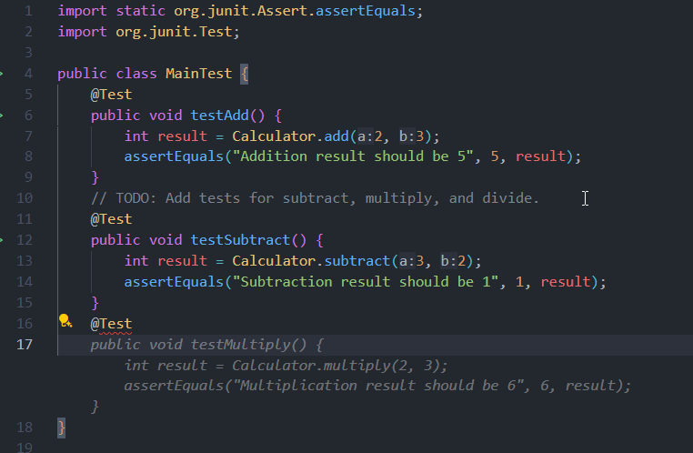

* 1. Save the test file.

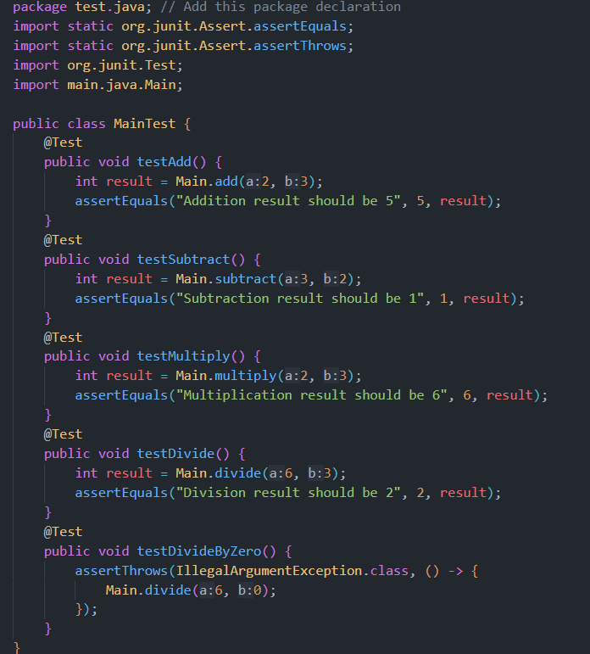

### **Implement the Feature in Main.java**

* 1. Open Main.java.
  2. **Write the Addition Function:**
     1. Begin with a comment:

| # Function to add two numbers |
| --- |

* 1. Then type the function signature:

| public class Calculator {  public static int add(int a, int b) {  return a + b;  }  // Implement other methods here } |
| --- |

GitHub Copilot may suggest further details; accept or modify as needed.

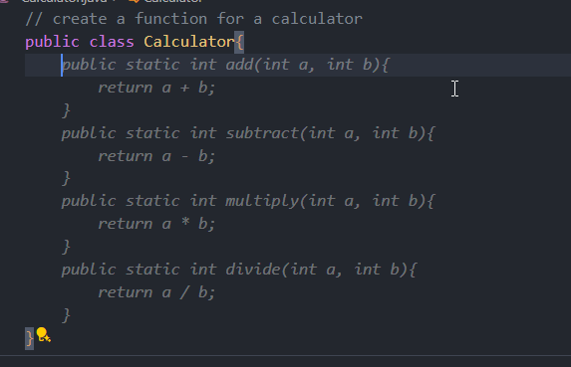

* 1. **Implement the Other Functions:**
     1. Similarly add functions for subtraction, multiplication, and division:

| public static int subtract(int a, int b) {  return a - b;  }   public static int multiply(int a, int b) {  return a * b;  }   public static double divide(int a, int b) {  if(b == 0) {  throw new IllegalArgumentException("Cannot divide by zero");  }  return (double)a / b;  } } |
| --- |

* 1. Save the file.

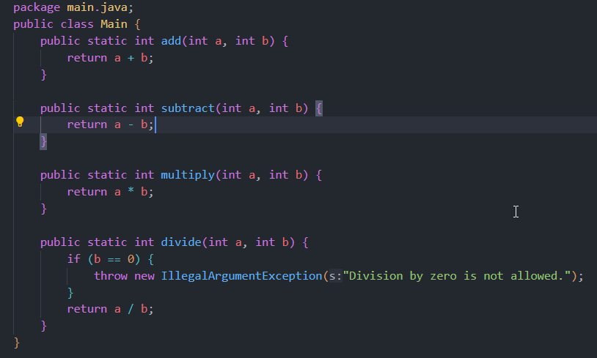

### **Run Your Tests**

* 1. Open the terminal.
  2. Run your tests using a tool such as mvn test or java’s built-in unittest. For example:

| mvn test |
| --- |

* 1. Ensure all tests pass. If a test fails, review the suggestions from Copilot and adjust your code accordingly.

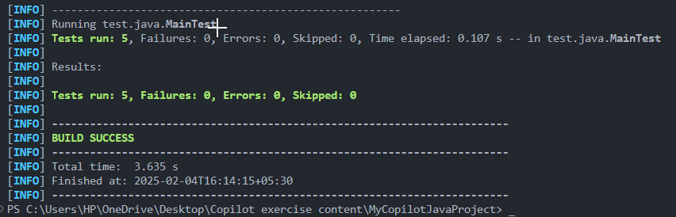

### **(Optional) Commit Your Changes**

* 1. In the terminal, run:

| git add . git commit -m "Implemented calculator functions using TDD in Java" |
| --- |

Voila!! We have successfully completed this exercise.